**Waxaad Cunugaaga u Joogteyn Kartaa Ilko-Cadeyn Caafimaad Qabta!**

Ilko Caafimaad Qaba Bar cad iyo Daloolo soo hormaray Daloolo qotodheeraaday

Cuntooyinka-Fudfudud (Snacks) Snac ( (Snacks)

Daloolada Ilkaha

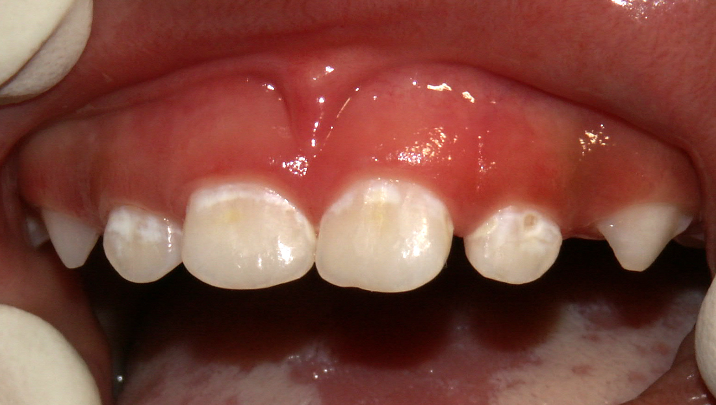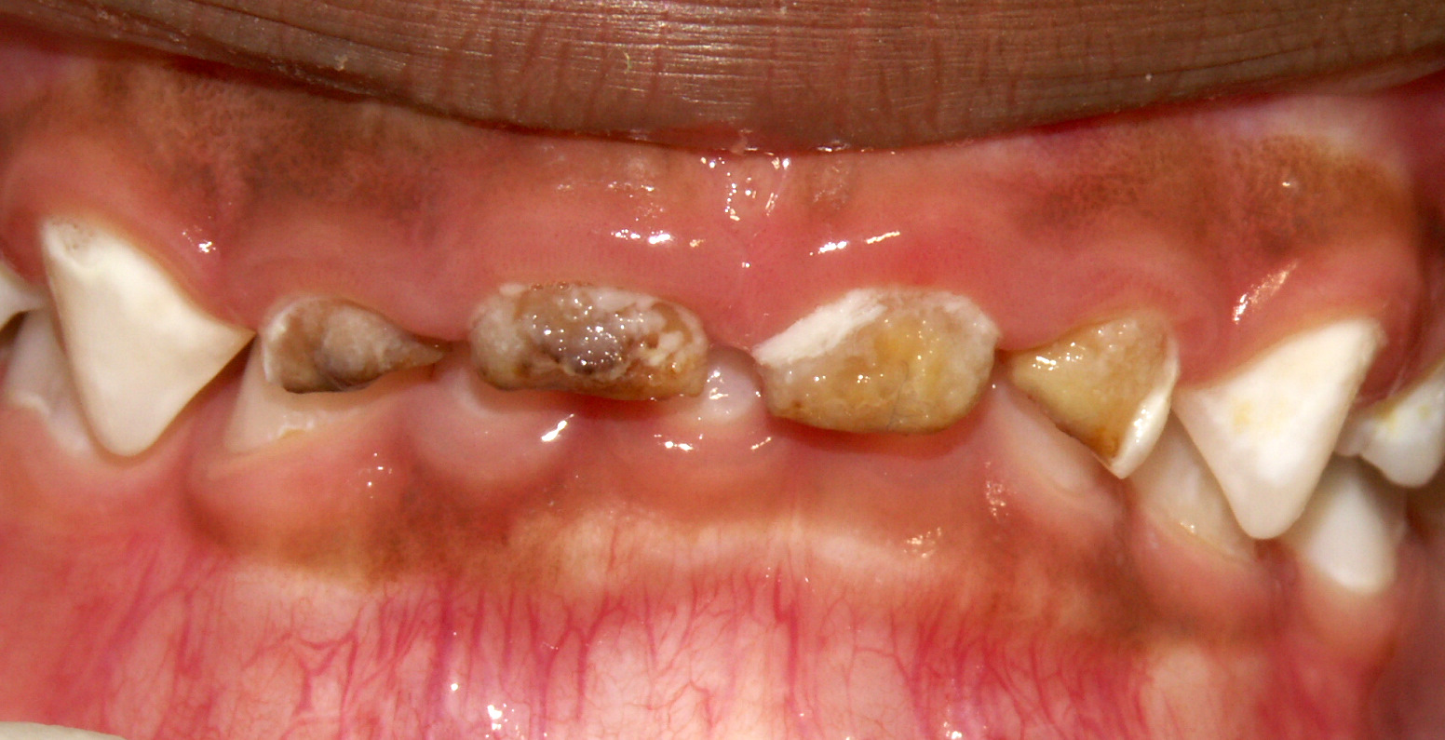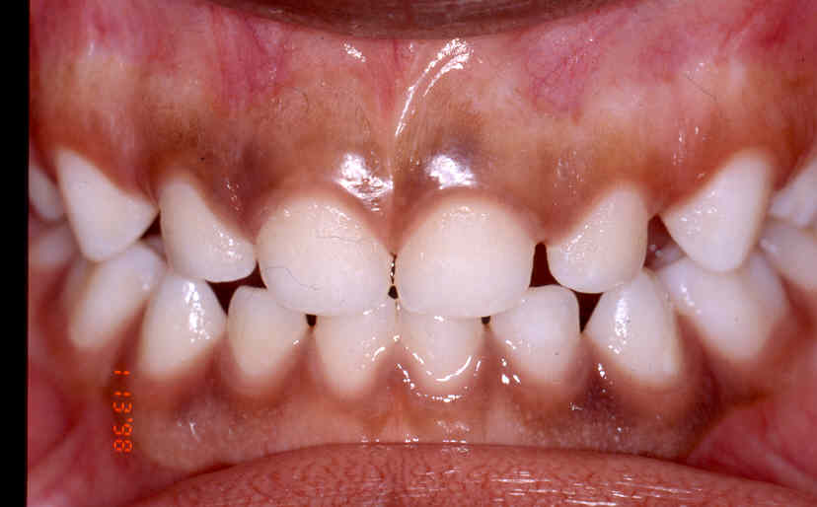

Cunugaaga booqashadiisa ilkaha ee koowaad waa in ay ahaato marka uu gaaro 12 bilood

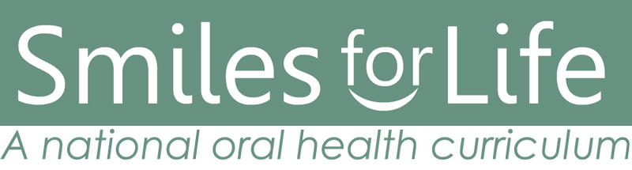

Developed by AB Douglass, MD, JM Douglass, BDS DDS, HJ Silk, MD

University of Connecticut Schools of Medicine and Dental Medicine

•**Cuntooyinka-fudfudud ee caafimaadka leh:**

**leh:**

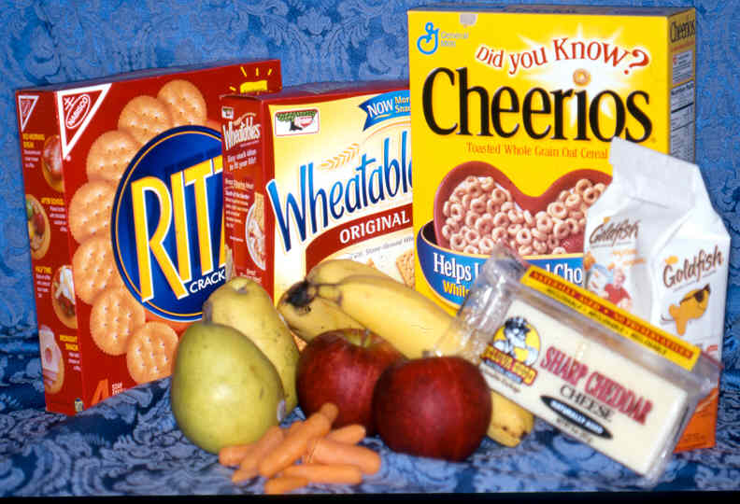

•Caruurta jirta sanad ama ka weymba sii caano ama biyo oo keliya cuntooyinka dhexdooda

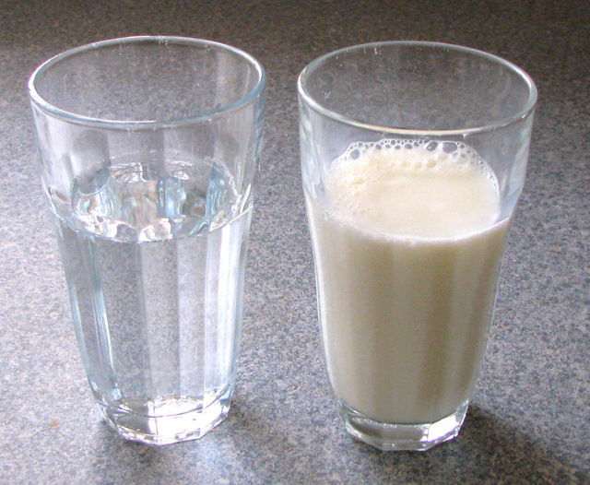

•Bilow isticmaalka koobka 6 ilaa 9 bilood inta u dhaxaysa

•Ha u ogolaan cunugaaga in uu la meereysto basaasad   ama koobka dhegaha leh midna

Koobabka (Cups)

•Maya cunto iyo   cabbitaan toona   cadayashada kaddib oo   ah waqtiga seexashada

•Fariiso ama staag dusha   dambe ee cunugaaga marka   aad u cadayesid

•Caday cirridada iyo ilkahaba

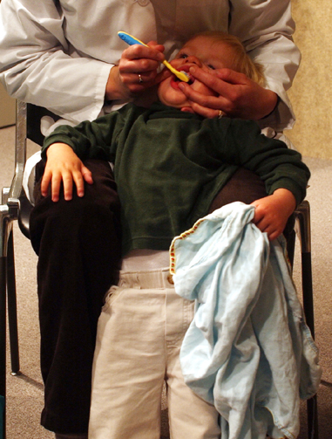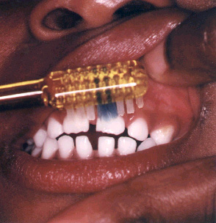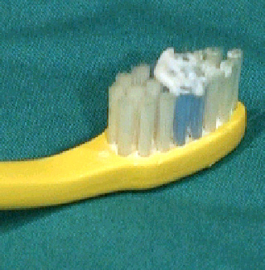

•Bilow mar alaale marka aad ilko   aragtid!

•Buraash yar oo jilicsan

•In yar oo daawada ilkaha oo  foloorayd leh

•Caruurta ka xafid daawada ilkaha in ay gaaraan

Ilkocadayshada (Toothbrushing)

•Hay cunugaaga marka uu basaasad wax ku cabayo

•Basaasadaha u isticmaal caanaha la qaso iyo kuwa   naaska oo keliya

•Maya in basaasadaha sariirta lala seexdo!

•Jooji isticmaalka basaasada marka la gaaro 12 bilood

Basaasadaha (Bottels)

Sida hadba in badan aad ka cuntid cuntooyinka sonkorta leh ayaa hadba in badan ilkahaaga daloolo ugu abuurmi karaan.

Farmaajo, Buskudyada, Miro daray-ah (cusub), Khudrooyinka , Cheerios saafi ah, Buskudyada xorshoshoda ah (pretzels)

Marka aad cuntid cuntooyin sonkor leh, bakteriyada afku waxay sonkorta u bedeshaa aashito. Ashitadu waxay dhaciifisaa ilkaha waxayna sababtaa baro cad cad oo ilkaha ku dhasha. Hadii aad joogteysid cunida sonkorta, baraha cad cad waxay isu bedelayaan daloolo. Dalooladu waxay horseedi karaan infekshino khatar ah.

•Hal cunto-fudud oo sonkor ka maran cuntooyinka   dhexdooda

•Maya badsashada cuntooyinka fudud (No “grazing”)!