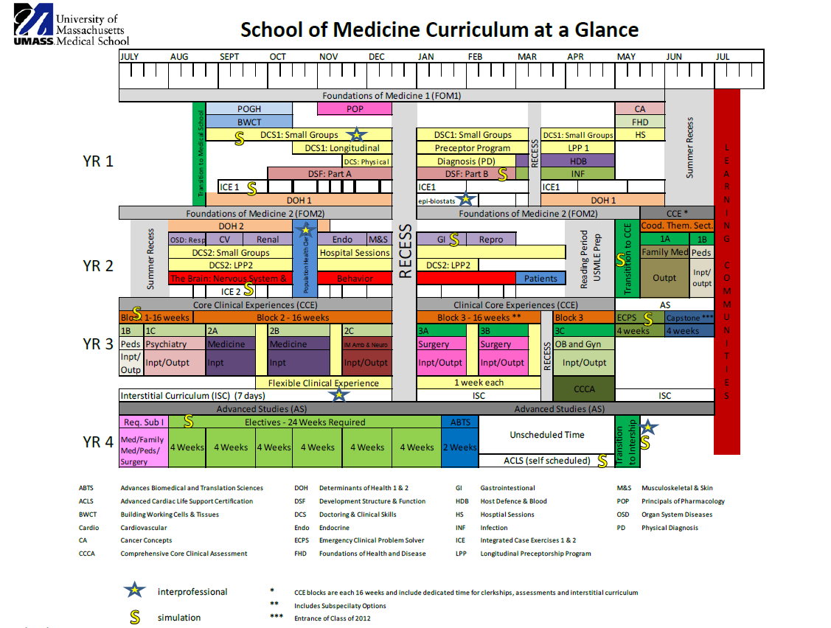

Oral health integration
New Oral Health Material

UMMS Oral Health Integrated Curriculum at a Glance:

FOM 1:
- PoHG (Principles of Human Genetics): Multi-Factorial Inheritance Lecture: Slides: Cleft palate is mentioned as a multi-factorial congenital trait and used as an example for a threshold trait.
Tumor Suppressors and Oncogenes (Cancer Genetics and Genomics) Lecture and Hereditary Cancer Syndromes Lecture: Slides: Mucosal Neuromas photos are shown in discussion of multiple endocrine neoplasia and in discussion of hereditary cancer syndromes.

- BWCT (Building Working Cells and Tissues): Lecture Conference, and Lab: Slides: Monkey lip and tongue are used in histology lecture and lab as a tool to identify different types of epithelium, muscle, and nerve bundles. Scurvy discussed including oral findings. Diabetes conference with discussion of periodontitis association with HbA1c.

- PoP (Principles of Pharmacology): Muscarinic Handout/Lecture: Slides: Mention of drugs used to treat xerostomia (pilocarpine).
Multiple Lectures: Mention of medications that can cause xerostomia and medications that stimulate the salivary glands. Additional clinical correlate of dry mouth and oral health effects including caries and fissured tongue.

- DSF (Development, Structure and Function): Block 6: GI: Overview of Oral Cavity/Esophagus Lecture: Slides: Discuss oral cavity and its role in digestion as well as sagittal cut diagram of oral cavity and neck. Mechanics of swallowing discussed.
GI Physiology Lecture: Slides: Saliva discussed in terms of production and function. Antibacterial and acid neutralization function of saliva and effect on teeth. Clinical photos showing effect of loss of saliva on mouth.
GERD Clinical Correlation Lecture: GERD linked to dental erosion.
- DSF: Block 8: Head and Neck: Cranial Nerves and Skull Overview Lecture: Slides: Innervation of salivary glands, palate, motor for lips and mouth, and bones that make up the oral cavity discussed (these topics are covered in multiple lectures in this block).
Anatomy of the Neck Lecture (Lecture and Dissection): Anatomy of the neck and dissection of the neck. Clinical importance of the retropharyngeal space discussed as well as the trauma zones of the head and neck including trauma to the oral cavity.
Oral Cavity Lecture: Review of spaces of the oral cavity along with anatomy of gums and teeth. Tooth numbering taught as well as neurovasculature of the oral cavity.
Oral Anatomy: Clinical Correlation Lecture: Discussion of clinical case of tooth pain and the progression of tooth infection to abscess to systemic infection. Lecture includes the discussion of social determinants of health affecting access to appropriate dental care. Stages of tooth decay discussed as well as the link between gum disease, mouth inflammation, and chronic illness.
Histology of Oral Cavity: Slides: Mucosa of lip, cheek, soft palate, tongue, gingiva, and hard palate discussed. Lip, tongue, and salivary gland micrographs discussed.
Pharynx and Larynx Lecture: Slides: Anatomy of these structures reviewed in lecture and dissection.
Development of Head and Neck Lecture: Slides: Embryological development of the oral cavity with mention of pharyngeal fistulas and cysts and the formation of cleft palates. Discussion of different types of cleft palates.
Lab/Dissection: Dissection of the oral cavity as well as dry lab with skulls to practice numbering teeth, oral terminology.
Study material: Image of the Day (IOD) with tooth numbering practice.
Exam: 2 oral health questions on unit exam.

- DCS 1 (Doctoring and Clinical Skills): Small group: Oral Health Review of Symptoms questions to ask in a patient interview. MOUTH: Condition of teeth, pain in mouth/tongue, bleeding gums, lesions in mouth, tongue or lips. 8. THROAT: Soreness, hoarseness, dysphagia.

- DOH (Determinants of Health), Epi-Bio Stats: Small group: Cohort study on periodontitis and CVD risk. Social determinants of health questions related to the paper for small group discussion.

- PD 1 (Physical Diagnosis): Small group: Perform head, neck, and proper systematic mouth exam (7 items). Use HEENOT. Faculty calibration on exam.
Exam: Tested on 7 oral exam items in the PD 1 practical examination.

- INF (Infections): Block 1:
Microbiome Lecture: Slides: Endocarditis (SBE) prophylaxis mentioned for high risk individuals who undergo oral procedures. Slide on oral biofilm, caries/cavities naming Streptococcus Mutans as the main cause of caries. Discussion of interaction between bacteria, sugar, and acid and the effects on tooth enamel. Link between local and systemic inflammation increasing risk for heart disease and diabetes.
Streptococci & Enterococci Lecture: Slides: Complications of GAS discussed including SBE. Additional slides added on dental flora.
Opportunistic Infection Lecture: Anaerobes linked to periodontal infection and aspiration pneumonia as well as human bite wounds. Graph showing correlation to specific bacteria and periodontitis. Slide on bacterial flora in subgingival crevice as well as the anaerobic flora in the oropharynx.
Spirochetes Lecture: Slides: Oral manifestations of secondary syphilis.
Patient Panel: Slides: Tonsillar abscess is focus of discussion.
- INF Block 2:
Fungi Lectures: Slides: Thrush, oral candidiasis, pictures and slides describing link to HIV and immunocompromised patients.
Small DNA Viruses Lecture: Slides: Human Papilloma Virus (HPV) link to head and neck and oropharyngeal cancers.
Herpes 1 and 2 Lectures: Slides: HSV with pictures of oral lesions, herpes labialis, and gingivostomatitis. Epstein Barr virus (EBV) infection and oral hairy leukoplasia correlation discussed with photos.
HIV Clinical Manifestations Lecture: Slides: Oral thrush, Kaposi’s sarcoma, oral hairy leukoplakia all discussed with clinical presentation.
Vaccines Lecture: HPV vaccine discussed to prevent oropharyngeal cancer.
Respiratory Viruses-Paramyxoviruses Lecture: Slides: Koplik’s spots mentioned as a key clinical presentation of Measles.

- Cancer Concepts: Histopathology Lab Lecture: Micrograph slides of tongue mass lesion shown and used as an example for stages of dysplasia as well as invasive cancer.
Anti-Cancer Drugs Lecture, Radiation Oncology Lecture, Cancer Prevention and Screening Lecture: Discussion of treatment for head and neck cancer as well as screening options.
Small Group 1: Signs of oral cancer and head and neck cancer discussed.
Small Group 4 Mock Tumor Board: Oropharyngeal cancer case used for the mock tumor board exercise. Additional oral health questions added to oropharyngeal cancer case covering effect of oral health on prognosis and treatment complications.

- Host, Defense and Blood (HDB): Iron Homeostasis and Anemia Lecture: Slides: Oral symptoms of anemia (glossitis, angular cheilitis, conjunctival and mucosal pallor)
Megaloblastic Anemia Lecture: Slides: Oral manifestations of megaloblastic anemia discussed including angular chelitis.
Acute Leukemia Lecture: Slides: Gingival hyperplasia, oral thrush opportunistic infection as a result of neutropenia.

- Foundations of Health and Disease (FHD): Nutrition Workshop: Slides: High sugar diet causing caries. Questions added about fluoride preventing cavities.
Nutrition modules: Fluoride facts and effect on teeth, sugar and the mouth.

FOM 2:
- Organ System Diseases (OSD):
Respiratory: Slides: Mouth infections, caries, periodontitis association with the risk of aspiration pneumonia.
Cardiovascular: Slides: Link between periodontitis, inflammation, and cardiovascular disease.
Musculoskeletal: Slides: Sjogrens disease (xerostomia) and temporomandibular joint syndrome (TMJ) discussed.
Gastrointestinal: Lecture: The Gateway to the GI tract and Systemic Illness: The Oral Cavity covering oral pathology and anatomy review including multiple oral lesions.

- DCS 2: Small Group: Students taught how to integrate dental and oral health maintenance questions into the patient interview.

- DOH 2: Oral health population health clerkship. Interprofessional (with nursing students) 2 weeks in the community in various dental settings including Headstart, Care mobile, correctional Health and exploring concepts like legislative effects on oral health, community water fluoridation and public health approaches including school-based fluoride varnish programs.

- The Brain: Nervous System & Behavior: Slides: TMJ, Facial Nerve Neuralgia Differential, Periodontitis and Dementia, Anti-cholinergic medication side-effects of xerostomia and clinical correlate

- Patients: Video review: Three-part Step 1 review on-line video modules of all oral health concepts covered on Step 1 based upon a review of USMLE summary document and First Aid review including cleft palate, oral lesions, medications affecting mouth, etc.

- Transitions to CCE: Pain Management: Slides: Discussion of Opioid Use Disorder and access to dental services. Link between oral health and self-esteem discussed.

FOM 3:
- Pediatric Clerkship: Module: Interpret skeletal and dental age and how it relates to maturation and adult height. CLIPP Aquifer module 3-year old child well visit includes review of importance of oral exam and fluoride varnish for prevention.
Clinical: exposure to fluoride varnish at some sites; oral concerns as they present.

- Family Medicine Clerkship: Case study, small group: Addition of offering fluoride varnish to pediatric patient. Adolescent tongue piercing oral health pros/cons discussed. Adult-no dental insurance, discussion about access to care.
Clinical: exposure to fluoride varnish at some sites; oral concerns as they present.

- Internal Medicine Clerkship: Online: Smiles for Life Geriatric Module for independent study.
Clinical: Medicare wellness exam and adult annual wellness exam; oral exam is a part of the entire physical exam practiced; oral concerns as they present.

- Flexible Clinical Experience (FCE): Clinical experience: A one-week oral health clinical experience of 5 different dental settings including an oral surgeon, pediatric dentist, prison dentist, dental hygienist on the care mobile, dental hygienist in a long-term care facility, a day in a craniofacial clinic, and/or a day with an adult dentist. Discussion on last day of concepts learned.

- Interstitial Curriculum:
Oral Health Interstitial: Full day - lectures, small groups: Link between oral health and diabetes and cardiac disease. Discussion about disease epidemiology and bacterial prophylaxis. Pediatric and adult oral health discussion in the setting of collaborative care as well as oral urgent care. Learn how to apply fluoride varnish along with indications for use and contraindications.
Veterans’ Health Interstitial: Lecture: Short oral health presentation related to veteran’s health including epidemiology of disease for recruits service members and veterans, care provided, and long term effects.
Disabilities Interstitial: Small group: Oral health as a selective topic as a part of the day exploring how oral health affects those with autism, cerebral palsy, Down syndrome including oral manifestations, care giver issues and local/national resources.

FOM 4:
- Electives: Clinical experience: Oral health elective - student works with local oral health offices, agencies, and outreach for 2-4 weeks with the objectives of appreciating the significance of oral disease on overall health, skills for oral health interview, learn local oral health resources, learn procedural skills, understand the team approach to oral care in various settings including hospital oral surgeon, dental hygiene school, geriatric dentist in nursing home, dental residency and correctional dental health.

- Emergency Clinical Problem Solver (ECPS): Lecture: Acute dental/oral problems and clinical problem solving with oral health pathology.
Clinical: oral urgent and emergent concerns as they present.

Pathways:
- Global Health Pathway: Lecture/Case Review 1.5 hours: Global oral health lecture and case review with global health dentist.
- Rural Health Pathway: Oral health lecture-discussion 1.5 hours: Rotating session every other year with rural dentist.

