Smiles for Life: A National Oral Health Curriculum

The Society of Teachers of Family Medicine (STFM)
Group on Oral Health- 4th Edition

Examination Items

Note: Answers to items appear on the final page.

Module 1: The Relationship of Oral to Systemic Health

- Which of the following are consequences of untreated dental decay?
  - Oral pain leading to poor school performance
  - Poor self-esteem
  - Costly restorations of diseased teeth
  - Emergency room visits for oral pain
  - All of the above are potential consequences of untreated dental decay

2. Tobacco users are at increased risk of developing which of the following conditions?
- Tooth fractures
- Oral thrush
- Oral cancer
- Bruxism (tooth grinding)

- Which condition is associated with periodontal disease?
- Asthma
- Preterm labor
- Sinusitis
- Hypothyroidism

- Which of the following medications is linked to gingival hyperplasia?
- Phenytoin
- Amoxicillin
- Digoxin
- Coumadin

- What can a primary care clinician do to promote oral health?
  - Collaborate with dental and other health professionals
  - Apply dental sealants
  - Prescribe oral fluoride supplements to every patient
  - Apply fluoride varnish to the teeth of all adults

Smiles for Life: A National Oral Health Curriculum

The Society of Teachers of Family Medicine (STFM)
Group on Oral Health- Third Edition

Module 1: The Relationship of Oral to Systemic Health (continued)

- Which of the following classes of medications is NOT generally associated with decreased salivary flow?
  - Antihistamines
  - Antibiotics
  - Corticosteroids
  - Anticholinergics
  - Diuretics

- Which of the following is true of the relationship loss of natural teeth (edentulism) and risk of death (mortality)?
  - Once over half of the teeth are lost, removing the remainder of the teeth and using dentures lowers risk of death.
  - Loss of all teeth before age 65 is associated with 1.5 times increased risk of death.
  - The study examining edentulism and mortality did not control for other confounding medical conditions.
  - The study examining edentulism and mortality was flawed because did not control for socioeconomic status and it is known that low socioeconomic status is associated with increased risk of death.

- Which of the following viruses has been linked to increased rates of oral cancer?
  - Human Papilloma Virus (HPV)
  - Hepatitis C Virus (HCV)
  - Epstein-Barr virus (EBV)
  - No virus has been linked to development of oral cancer

- What is the suggested common pathway linking chronic periodontitis and conditions such as diabetes, coronary artery disease, and adverse pregnancy outcomes?

  - Direct bacterial extension
  - Poor nutrition
  - Circulating antibodies
  - Inflammation

- Which of the following complex conditions are ideal for co-management between medical and dental teams?
  - Anticoagulation management
  - Antibiotic prophylaxis prior to dental procedures
  - Opioid management for dental pain
  - All of these conditions are ideal for co-management between medical and dental teams
Smiles for Life: A National Oral Health Curriculum

The Society of Teachers of Family Medicine (STFM)
Group on Oral Health - Third Edition

Module 2: Child Oral Health

- What is Early Childhood Caries?
  - Dental caries in children from 2–10 years of age
  - Microbial imbalance causing chronic disease
  - Deformities in a child’s teeth caused by excessive fluoride ingestion during tooth formation
  - Dental decay caused by a lack of fluoride in a child’s diet

- Oral bacteria and dietary sugars are two of the three parts of the “Etiology Triad” of
Early Childhood Caries. What is the third part of the triad?
  - The enamel and dentin of teeth are vulnerable to demineralization
  - Bacterial toxins attach the teeth’s calcium matrix
  - Saliva provides a moist environment for growth of cariogenic (cavity-causing) oral bacteria
  - Genetic predisposition to overgrowth of cariogenic (cavity-causing) oral bacteria

- What is a risk factor for developing Early Childhood Caries?
  - High fat diet
  - A patient’s age
  - Excessive levels of fluoride
  - Caries in siblings or caretakers

- How can primary care clinicians help prevent Early Childhood Caries?
  - Counsel caregivers about the child’s diet
  - Apply dental sealants to the teeth of young patients
  - Prescribe fluoride to every young patient
  - Refer children to a dentist at age 5

- The mother of a 10-month old patient asks for a prescription for supplemental fluoride. She reports that the family obtains their water from a well. What is your best course of action?
  - Prescribe a dietary fluoride supplement as well water does not contain fluoride
  - Test the well’s fluoride level prior to prescribing a dietary fluoride supplement
  - Do not prescribe a dietary fluoride supplement as the child has neither white spots nor dental caries
  - Obtain the fluoride level in wells near the family’s home from the local health department before prescribing a dietary fluoride supplement

Smiles for Life: A National Oral Health Curriculum

The Society of Teachers of Family Medicine (STFM)
Group on Oral Health - Third Edition

Module 2: Child Oral Health (continued)

6. What does this photograph of a child’s mouth depict?
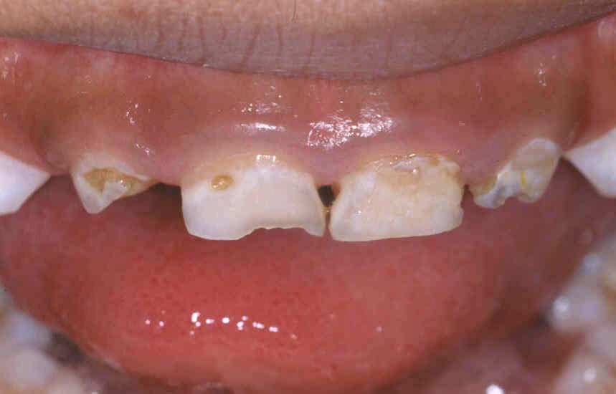

  - Fluorosis
  - White spot lesions
  - Severe Early Childhood Caries
  - Iron staining

- To what is the arrow pointing on this photograph of a child’s mouth?
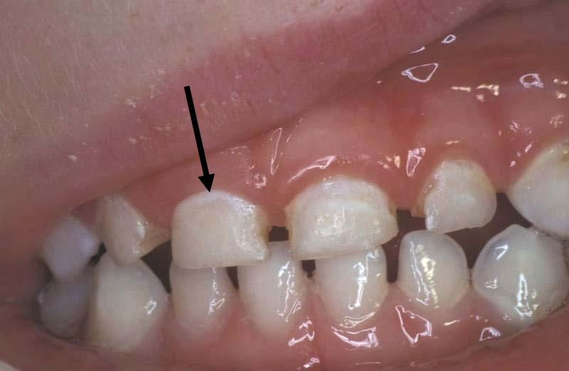

- A normal tooth
- Fluorosis
- White spot lesions of Early Childhood Caries
- Severe Early Childhood Caries

Smiles for Life: A National Oral Health Curriculum

The Society of Teachers of Family Medicine (STFM)
Group on Oral Health - Third Edition

Module 2: Child Oral Health (continued)

- What is the first step in performing a knee-to-knee oral examination of a child’s mouth?
  - Have the caregiver hold the child on their lap facing the examiner
  - Have the caregiver hold the child facing them in a straddle position
  - The examiner looks in the child’s mouth
  - Have the caregiver separate the child’s jaws

- What guidance about teething should a primary care clinician provide to a toddler’s caregiver?
  - Teething can cause ear infections, fever, and diarrhea
  - The caregiver should bring the toddler to the office if the child starts to drool
  - Teething sometimes causes upper respiratory infections
  - A child who is teething may be fussy

- The arrow is pointing to a darkened feature in a child’s mouth. What is this finding called?
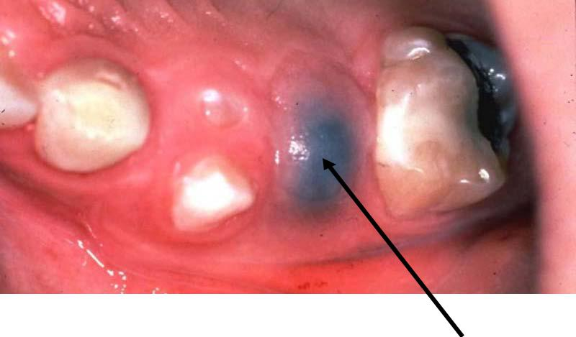

- Fluorosis
- An avulsed tooth from trauma
- An eruption hematoma
- Early childhood caries in an unerupted tooth

Smiles for Life: A National Oral Health Curriculum

The Society of Teachers of Family Medicine (STFM)
Group on Oral Health - Third Edition

Module 3: Adult Oral Health

- Which of the following dental procedures does NOT require antibiotic prophylaxis for individuals at high risk of bacterial endocarditis?
  - Routine fillings
  - Post-operative suture removal
  - Dental cleaning
  - Fluoride treatments
  - Orthodontic appliance adjustment

- Which clinical finding distinguishes periodontitis from gingivitis?
  - Inflammation of the gums
  - White discoloration of the permanent teeth
  - Enlarged pockets at the gum base
  - Gingival hypertrophy

- Which of the following is the least common site for the development of oral cancer?
  - The tongue
  - Floor of mouth
  - Hard palate
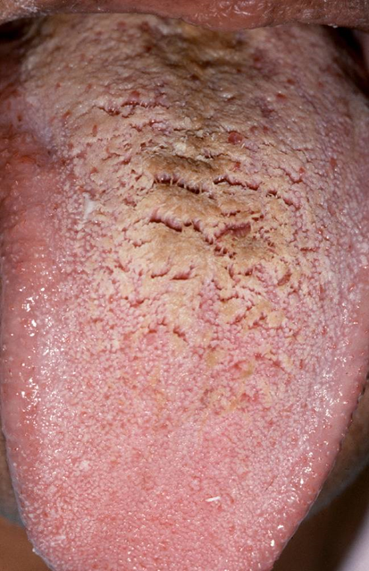
Photo courtesy of Brad Neville, DDS

  - Lower lip

- How would you best manage the oral finding noted in the photo on the right?
  - Biopsy
  - Referral to oral surgeon
  - Treat with topical antibiotics
  - Regular tongue brushing

- Which of the following factors reduces the risk for caries in adults?
    - Low socioeconomic status
    - Existing tooth restoration
    - A vegetarian diet
    - Decreased salivary flow
    - Low sugar diet
Smiles for Life: A National Oral Health Curriculum

The Society of Teachers of Family Medicine (STFM)
Group on Oral Health - Third Edition

Module 3: Adult Oral Health (continued)

- Which of the following patients require bacterial endocarditis antibiotic prophylaxis?
    - A 26-year-old woman with mitral valve prolapse undergoing routine teeth cleaning with no anticipated bleeding.
    - A 64-year-old man with a prosthetic mitral valve who is undergoing a tooth extraction.
    - A 16-year-old boy with a ventricular septal defect completely repaired in infancy who requires extraction of an impacted wisdom tooth.
    - A 32-year-old man who had bacterial endocarditis 5 years ago who is undergoing orthodontic appliance adjustment.

- Which of the following is an abnormal tooth change not explained by aging alone?
    - Gingival recession
    - Root caries
    - Yellowing of teeth
    - Wearing away of teeth with exposed dentin

- Which of the following statements concerning xerostomia, or dry mouth, is NOT true?
    - Xerostomia is caused by a decrease in the production of saliva.
    - Xerostomia can cause a burning sensation, change in taste, and difficulty swallowing.
    - Medications can contribute to the development of xerostomia.
    - Xerostomia increases risk for the development of caries.
    - Xerostomia is rarely a problem for patients wearing complete dentures.

- Which of the following has been implicated in the development of recurrent aphthous ulcers?
  - Trauma
  - Vitamin C deficiency
  - Sickle Cell Anemia
  - Herpes simplex virus infection
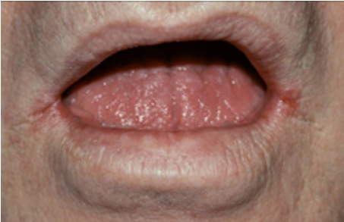
Photo courtesy of Brad Neville, DDS
- What is the most appropriate initial management for the patient in the photo to the right?
  - Treat with topical antifungals
  - Refer to dermatology
  - Biopsy
  - Treat with oral antibiotics
  - Treat with topical antiviral medication

Smiles for Life: A National Oral Health Curriculum

The Society of Teachers of Family Medicine (STFM)
Group on Oral Health - Third Edition

Module 4: Acute Dental Problems and Emergencies

- Which antibiotic is the drug of choice for intra-oral infections?
  - Ciprofloxacin
  - Doxycycline
  - Amoxicillin
  - Cefuroxime

- When should an avulsed tooth in a 35-year old patient be optimally re-implanted?
  - It should not be re-implanted
  - Within 1 hour
  - Within 12 hours
  - Within 24 hours

- Tongue piercings put patients at risk for which of the following problems:
  - Tooth fractures
  - Maxillary tori
  - Oral cancer
  - Tooth abscess

- When should an avulsed baby tooth in a 2-year old be re-implanted?
  - It should not be implanted
  - Within 5 minutes
  - Within 1 hour
  - Within 12 hours

- Which of the following is an indication for hospitalization of an adult with facial cellulitis?
  - Localized facial swelling
  - Fever
  - Tracking of swelling into the neck
  - Difficulty chewing

Smiles for Life: A National Oral Health Curriculum

The Society of Teachers of Family Medicine (STFM)
Group on Oral Health - Third Edition

Module 4: Dental Emergencies (continued)

- Which type of mouth guard provides the most protection against oral injury in sports?
  - Stock
  - Self-adapted (boil and bite)
  - Custom made

- Which of the following conditions requires treatment with antibiotics?
  - Peri-apical abscess
  - Cellulitis
  - Caries
  - Pulpitis

- What is the most appropriate treatment for a chipped tooth?
  - Routine referral to a dentist to smooth or restore the chip
  - Emergent referral to a dentist
  - Go to the emergency department immediately
  - Application of iodine to prevent a root infection

- What would you do first in evaluating a patient with facial trauma?
  - Find any missing teeth
  - Determine if any teeth have been fractured
  - Evaluate the gum line for bleeding
  - Assess the patient’s airway, breathing, and circulation

- The treatment of choice for an abscessed tooth is:
  - Oil of Clove
  - Oral antibiotics
  - Pain medication
  - Dental referral for extraction or root canal treatment

Smiles for Life: A National Oral Health Curriculum

The Society of Teachers of Family Medicine (STFM)
Group on Oral Health - Third Edition

Module 5: Pregnancy and Women’s Oral Health

- Which of the following is a FALSE statement?
  - Gingivitis is very common in pregnancy
  - Periodontitis is associated with preterm birth
  - Treatment of periodontitis in pregnancy decreases the risk of preterm birth
  - Deep root scaling to improve periodontitis is safe during pregnancy

- Which of the following is a TRUE statement?
  - Mothers with caries pass their genetic predisposition for caries on to their babies
  - Mother with caries pass caries-causing bacteria to their babies in utero
  - Mother with caries pass caries-causing bacteria to their infants early in life via saliva transmission
  - Mothers who breastfeed pass antibodies to their infants that protect against caries

- A pregnancy granuloma:
  - Has malignant potential and should be biopsied
  - Should be excised during pregnancy even if asymptomatic to avoid complications
  - Can be observed
  - Is not likely to recur if excised

- A pregnant patient asks you for guidance about having dental treatment during her pregnancy. What would you say?
  - Dental treatment should only be performed during the second and third trimesters
  - Dental treatment should only be performed during the third trimester after organ formation is complete
  - Dental treatment should only be performed during the second trimester for comfort and safety reasons
  - Dental treatment can be performed during any trimester

- What guidance should you give a pregnant patient about having dental X-rays during pregnancy?
  - Dental x-rays should be avoided during pregnancy
  - Dental x-ray should be limited to only one film per pregnancy
  - Dental x-rays should be taken as necessary to reach an appropriate diagnosis
  - Dental x-rays are rarely needed during pregnancy

Smiles for Life: A National Oral Health Curriculum

The Society of Teachers of Family Medicine (STFM)
Group on Oral Health - Third Edition

Module 5: Oral Health in Pregnancy (continued)

- What oral health guidance should you give a pregnant patient?
  - Brush twice daily with non-fluoridated toothpaste
  - Use chlorhexidine mouthwash three times per day
  - Avoid sugary drinks and snacks between meals
  - Take dietary fluoride supplements daily

- If a pregnant woman has an oral abscess in the first trimester, what should she do regarding treatment?
  - Take antibiotics and pain medication only and wait until her second trimester to see the dentist
  - Avoid x-rays for diagnosis as they are especially harmful to the fetus in the first trimester
  - Have the tooth treated or extracted under local anesthesia immediately
  - Delay definitive treatment until after delivering the baby

- Which of the following statements is most true about amalgam (silver and mercury) fillings placed during pregnancy?
  - Amalgam fillings are the most appropriate filling type for pregnant women.
  - They should be avoided there are risks associated with placement of all types of fillings, not just amalgam fillings.
  - Amalgam fillings are safe in pregnancy, but contraindicated in women who are breastfeeding
  - White resin composites are preferred as they are believed to be safe during pregnancy and breastfeeding.

- What can pregnant women do after vomiting to reduce the risk of enamel erosion?

  - Swish with baking soda and water
  - Vigorously brush her teeth
  - Immediately take a dose of a proton pump inhibitor
  - Immediately take 3 to 4 antacid tablets

- All of the following conditions can cause worsening gingivitis EXCEPT:
  - Onset of puberty
  - Monthly menses
  - Menopause
  - Use of oral contraceptives
  - Pregnancy
Smiles for Life: A National Oral Health Curriculum

The Society of Teachers of Family Medicine (STFM)
Group on Oral Health - Third Edition

Module 6: Caries Risk Assessment, Fluoride Varnish and Counseling

- The mother of a 9-month old patient asks what causes early childhood caries (ECC). Which of the following is the most accurate reply?
  - The majority of ECC results from thin or “weak” tooth enamel inherited from the parents
  - Microbial imbalance in the mouth creates acid that damages tooth enamel
  - A lack of protective saliva is the most common cause of ECC
  - A calcium deficiency during tooth formation produces teeth that lack a sufficiently thick covering of enamel

- Which of the following factors places a child at the most risk for developing early childhood caries?
  - Having a diagnosis of asthma.
  - Living with family members who smoke tobacco
  - Breast feeding for less than six months
  - Having existing white spots or calcifications

- Which of the following is the major mechanism of action of topical fluoride in caries prevention?
  - It promotes saliva release which neutralizes acids on the tooth surface
  - It promotes remineralization of the teeth
  - It inhibits demineralization of the teeth
  - Both B and C are true

- Which of the following is a benefit of fluoride varnish?
  - Fluoride varnish permanently seals the pits and fissures of teeth
  - Fluoride varnish decreases the need for routine dental care
  - Fluoride varnish can reverse early decay and slow enamel destruction
  - Fluoride varnish replaces the need to take systemic fluoride supplements
Smiles for Life: A National Oral Health Curriculum

The Society of Teachers of Family Medicine (STFM)
Group on Oral Health - Third Edition

Module 6: Caries Risk Assessment, Fluoride Varnish and Counseling (continued)

- While performing an exam on one of your young patients, you observe the following (see photograph below). Describe what you see:

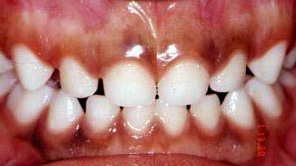

  - The teeth are normal and have no white spots or tooth decay
  - The gingiva (gums) are pathologically pigmented
  - The tooth’s enamel is thin, so fluoride varnish must be applied to strengthen the enamel
  - The color of the teeth indicate that this child is at high risk for developing fluorosis

- What guidance would you provide the mother of your 20-month old patient who expresses concern about her child developing fluorosis? The family lives in a town that adds fluoride to the water supply and the child has already had 2 cavities.
  - Recommend to use only a small smear of fluoridated toothpaste when brushing the child’s teeth
  - Recommend the mother use a non-fluoridated toothpaste
  - Recommend to brush the child’s teeth every other day
  - Recommend to only give bottled drinking water to the child

- According to the U.S. Preventive Services Taskforce (USPSTF) recommendations, which children should receive fluoride varnish in the medical office?
  - All children at high risk for caries
  - High risk children without a dental home
  - Low risk children
  - All children under age 6

Smiles for Life: A National Oral Health Curriculum

The Society of Teachers of Family Medicine (STFM)
Group on Oral Health - Third Edition

Module 6: Caries Risk Assessment, Fluoride Varnish and Counseling (continued)

- While performing an exam on one of your young patients, you observe the findings on the teeth indicated by the yellow arrows (see photograph below). Describe the tooth’s condition.
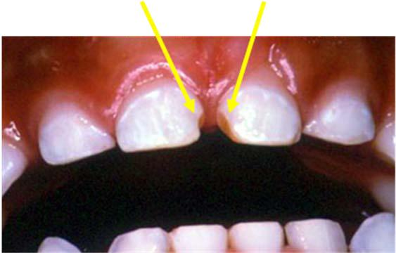

  - The teeth are normal and have no visible dental caries
  - The brown areas represent caries where loss of overlying enamel has exposed underlying dentin
  - The brown discoloration indicate areas that the child has chipped his teeth
  - The brown color indicates that the child has developed fluorosis

- When applying fluoride varnish to an infant, what is the most important function of the gauze?
  - The gauze is the vehicle used to apply the flourish varnish to the teeth
  - The gauze is used to hold the tongue out of the way
  - The gauze is used to dry the child’s teeth
  - The gauze is shown to the child to stimulate her to open her mouth

- What guidance do you give the grandmother of a child who just had fluoride varnish applied to his teeth?
  - The child’s teeth will be discolored for about a week
  - Do not brush the child’s teeth for at least 48 hours
  - Brush the child’s teeth in about one hour
  - Avoid giving the child hot, sticky, or hard foods for at least 6 hours

Smiles for Life: A National Oral Health Curriculum

The Society of Teachers of Family Medicine (STFM)
Group on Oral Health - Third Edition

Module 7: The Oral Examination

- What constitutes a tooth’s outer layer?
  - Enamel
  - Dentin
  - Pulp
  - Cementum

- What is a full complement of adult teeth?
  - 26
  - 28
  - 30
  - 32

- A caregiver asks you how many teeth her 3-year old child should have. What is the most appropriate response?
  - 20
  - 22
  - 24
  - 28

- At what age do teeth typically begin to erupt in children?
  - Before 6 months of age
  - 6-15 months of age
  - 15-21 months of age
  - 21-27 months of age

- Oral cancer is most common in which area of the mouth?
  - Hard palate
  - Top surface of the tongue
  - Inside of the cheeks
  - Posterolateral surface of the tongue
Smiles for Life: A National Oral Health Curriculum

The Society of Teachers of Family Medicine (STFM)
Group on Oral Health - Third Edition

Module 7: The Oral Examination (continued)

- When performing the “knee-to-knee” oral exam on a young child, in what position should the child start?
  - Facing the examiner
  - Standing up
  - Sitting on the exam table
  - Facing the caregiver

- All of the following are needed by a primary care clinician to conduct a thorough oral exam EXCEPT for?
  - An exam light to illuminate key features in the mouth
  - Tongue depressor to lift the lip and retract the cheek
  - A mouth mirror to view the lingual surfaces of teeth
  - Gauze pad to grasp the tongue

- When examining the mouth of a 9-month old child, which of the following is a reason for early referral to see a dentist?
  - The child has only 4 incisors
  - Developmental tooth defects are present
  - Molars are not present
  - Canine teeth are not present

- You are performing an oral exam on a 21-year old patient who has been using smokeless tobacco for 4 years. Which part of this patient’s oral cavity is especially important for you to examine?
  - Sun-exposed areas of the cheeks
  - Inner aspect of the lips and cheeks
  - Discoloration or pitting of the patient’s teeth
  - Plaque build-up along the patient’s gum line
  - Posterior pharynx

- A complete oral examination includes assessment of each of the following EXCEPT:
  - Temporomandibular joint (TMJ)
  - Cervical nodes
  - Palpation of the floor of the mouth
  - Sinuses
  - Skin around the mouth
Smiles for Life: A National Oral Health Curriculum

The Society of Teachers of Family Medicine (STFM)
Group on Oral Health - Third Edition

Module 8: Geriatric Oral Health

- What is the most common site for recurrent caries in the elderly?
  - The site of a previous restoration (filling)
  - On a root that is exposed due to gingival recession
  - On the coronal surface of a tooth
  - On the buccal surface of the molars

- Which of the following is an absolute contraindication for placing dental implants?
  - Diabetes mellitus that is controlled
  - Root caries in the teeth that are to be replaced
  - The use of IV bisphosphonates
  - The use of medication known to cause xerostomia

- Calcium channel blockers are most associated with which adverse intraoral effect?
  - Stomatitis
  - Thrush
  - Gingival hyperplasia
  - Osteonecrosis of the mandible

- Which statement is true regarding dental prostheses?
    - Implants are commonly placed in a jaw to replace teeth lost due to severe osteoporosis
  - Dentures should be removed and cleaned daily
  - Bridges should be removed daily to facilitate cleaning of teeth
  - A partial denture is permanently fixed to adjacent teeth and therefore does not need to be removed to perform a complete oral assessment

- HPV influenced oral cancers have which of the following characteristics?
    - Account for the rise in oral cancers in younger individuals, ages 40-64
    - Are usually seen in the anterior portion of the mouth, especially the buccal mucosa or lips
    - Epidemiologically related to exposure to HPV 18
    - Less likely to be associated with oral cancer than other sexually transmitted infections such as syphilis and gonorrhea
Smiles for Life: A National Oral Health Curriculum

The Society of Teachers of Family Medicine (STFM)
Group on Oral Health - Third Edition

Module 8: Geriatric Oral Health (continued)

- What is the most likely reason why complete tooth loss has declined in the US from 50% to 18% over the last 60 years?
  - The increased use of dental insurance among the elderly
  - The increased use of bottled and filtered water products among adults
  - The addition of fluoride to most community water systems
  - The increased use of multiple prescription medications in the elderly

- While performing an oral exam on a 72-year old patient, you observe the finding in the photograph below. How should you manage this finding?
    - Refer the patient to an oral surgeon for immediate biopsy of a probable oral cancer
    - Schedule the patient to return in 2 weeks to reassess the lesion. If the lesion is still present, you should then refer the patient for biopsy
  - Treat the patient with an antifungal solution and reassess in 2 weeks
  - Document this finding as sublingual varicosities that are normal in this age group and require no further evaluation
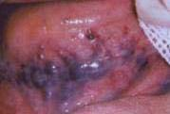

Photo courtesy of Robert Henry, DMD, MPH

8. Which of the following statements is true regarding the oral health of elderly patients with dementia?
- Age alone is the major contributor to poor oral health of older individuals with dementia

  - Medications used to treat hypertension, depression, and behavioral disturbances seen in this population have little effect on their oral health
  - Since this population struggles with Activities of Daily Living (ADLs), they are at high risk for poor oral health unless caregivers assist with oral care
  - Reminding these individuals to brush their teeth each day is adequate to achieve and maintain good oral health

Smiles for Life: A National Oral Health Curriculum

The Society of Teachers of Family Medicine (STFM)
Group on Oral Health - Third Edition

Module 8: Geriatric Oral Health (continued)

9. After a hip fracture, a 76 year old woman is admitted to a long-term care facility for rehabilitation. While examining her mouth shortly thereafter, you see the condition in the photograph below. What is the most likely cause of what you see?
- The patient developed cellulitis of her palate during her recent hospital stay
- The patient’s palate was damaged during intubation for anesthesia
- The patient’s dentures were improperly cleaned while she was in the hospital
- The patient probably has oral cancer
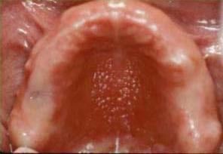

Photo courtesy of Robert Henry, DMD, MPH

- Elderly with poor oral hygiene, missing teeth, and dental pain are at risk for worsening oral health due to which of the following nutritional factors?
  - Lack of foods rich in vitamins such as vitamin C and beta carotene.
  - Compensating for taste alteration due to prescribed medication with soft, sugared foods such as ice cream, pudding and white bread which can lead to caries in remaining teeth.
  - Use of mints or sweetened beverages to relieve dry mouth.
  - All of the above.

Smiles for Life: A National Oral Health Curriculum

The Society of Teachers of Family Medicine (STFM)
Group on Oral Health - Third Edition

Answers

Module 1 |  | Module 4 |  | Module 7
1. | E | 1. | C | 1. | A
2. | C | 2. | B | 2. | D
3. | B | 3. | A | 3. | A
4. | A | 4. | A | 4. | B
5. | A | 5. | C | 5. | D
6. | B | 6. | C | 6. | D
7. | B | 7. | B | 7. | C
8. | A | 8. | A | 8. | B
9. | D | 9. | D | 9. | B
10. D |  | 10. D |  | 10. D

Module 2 |  | Module 5 |  | Module 8
1. | B | 1. | C | 1. | A
2. | A | 2. | C | 2. | C
3. | D | 3. | C | 3. | C
4. | A | 4. | D | 4. | B
5. | B | 5. | C | 5. | A
6. | C | 6. | C | 6. | C
7. | C | 7. | C | 7. | D
8. | B | 8. | D | 8. | C
9. | D | 9. | A | 9. | C
10. C |  | 10. C |  | 10. D
Module 3 |  | Module 6
1. | D | 1. | B
2. | C | 2. | D
3. | C | 3. | D
4. | D | 4. | C
5. | E | 5. | A
6. | B | 6. | A
7. | B | 7. | D
8. | E | 8. | B
9. | A | 9. | C
10. A |  | 10. D

© The Society of Teachers of Family Medicine 2010. All rights reserved.

