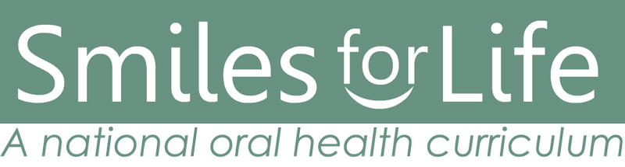
Media Contact: Maggie Palmer, MKP Creative
maggie@mkpcreative.com | 503.419.7677

Smiles for Life, A National Oral Health Curriculum, Launches
New Website and Updated Edition of Its Innovative and Accessible Curriculum for Educators, Students and Primary Care Providers

Oct. 22, 2020––Smiles for Life, a free online educational resource designed to ensure the integration of oral health and primary care, announced today the launch of its new, easy to use, smilesforlifeoralhealth.org website and app. The site includes the recently updated edition of its widely praised curriculum and enhanced set of educational tools and resources.
”Good oral health is more than just preventing cavities,” said Dr. Melinda Clark, Smiles for Life editor, pediatrician and professor at Albany Medical Center in New York. “Poor oral health impacts a variety of conditions such as preterm birth, diabetes, obesity and cancer. Because 60 million Americans lack proper access to dental care, Smiles for Life was developed to integrate oral health with primary care, literally saving lives.”

The Smiles for Life curriculum, endorsed by more than 20 professional organizations, is offered free of charge to health care providers, students and educators. It consists of eight 60-minute modules covering core areas of oral health. The curriculum is also certified for continuing education credits across multiple professions including physicians, nurses, PA’s, medical assistants, pharmacists, and dental health professionals. Users measure their progress through assessments at course completion. Those who score 80% or higher receive credit for each course.

Clark added, “Smiles for Life offers off-the-shelf resources, making it easy to incorporate oral health directly into your practice or classroom curriculum.”
Tools include patient handouts and posters in multiple languages, patient care training videos, guidelines and statements, publications, clinical cases, and more. All content is downloadable, so educators can easily incorporate the content into action. The curriculum can also be used to satisfy interprofessional educational standards, and includes an app that can be used as a reference tool designed to assist primary care providers in formulating a diagnosis in real-time. Clinicians select an algorithm based on the presenting concern of the patient or physical exam finding, and the decision tool presents a series of questions to help formulate a diagnosis, triage and treatment plan.

About Smiles for Life
Smiles for Life produces educational resources to ensure the integration of oral health and primary care. Smiles for Life, a national oral health curriculum, was originally developed in 2005 by the Society of Teachers of Family Medicine Group on Oral Health. Smiles for Life is now the nation's most comprehensive and widely used oral health curriculum for primary care clinicians. It has been officially endorsed by more than 20 national organizations, and is in wide use in professional schools and post-graduate training programs. There is no cost to participate in the program, and Smiles for Life is certified for continuing education requirements.

Smiles for Life is funded by the National Interprofessional Initiative on Oral Health (NIIOH), whose activities are made possible by a collaborative network of funders sharing a common commitment to enhancing the role of primary care clinicians in the promotion of oral health. To learn more please visit smilesforlifeoralhealth.org

# # #

