Authors’ note: The details of this case can be adapted to meet any institution’s geographic location. Notes have been added in italics throughout to assist in adapting this case.

Case Title: Primary oral HSV infection (gingivostomatitis)- Telemedicine
Case Authors: Muhammad Ali Shazib, Rocio Quinonez, Ryan Palmer
Time Allotted for Case: 15-20 minutes (+5 minutes of feedback)

Scenario: Patient with lip and mouth lesions referred by local college student health services.

Objectives:
- Utilize telemedicine video technology to perform history taking, examination and review of pertinent clinical data of a patient with primary oral herpes infection.
- Differentiate primary oral herpes infection from other lesions such as secondary oral HSV infection (recurrent herpes labialis/cold sore), erythema multiforme (EM), and recurrent aphthous stomatitis (RAS).
- Present and summarize case to faculty preceptor on teleconsult/video conference service.
- Establish and maintain patient rapport in digital context of visit.

Recommended Assessed Competencies
CODA | LCME | AAMC EPAs
Educational program (2-5) The dental education program must employ student evaluation methods that measure its defined competencies. (OSCE) |  | Gather history and physical examination (EPA 1)  Prioritize differential diagnosis after a clinical encounter (EPA 2)
Critical thinking (2-10) Graduates must be competent in the use of critical thinking and problem-solving,  including their use in the comprehensive care of patients, scientific inquiry and  research methodology. | Curricular content (7.2)  Organ systems/life cycle/ symptoms/ signs/ differential diagnosis/ treatment planning | Recommend and interpret common diagnostic and screening tests (EPA 3)  Enter and discuss orders and prescriptions (EPA 4)
Self- assessment (2-11) Graduates must demonstrate the ability to self-assess, including the development  of professional competencies and the demonstration of professional values and capacities associated with self-directed, lifelong learning. | Critical Judgment/Problem-Solving Skills (7.4) | Document clinical encounter in patient record (EPA 5)  Form Clinical Questions and Retrieve Evidence to Advance Patient Care (EPA 7)
Biomedical sciences (2-12 to 2-15)  Graduates must be able to demonstrate the ability to understand basic biological principles, interrelationship between the orofacial complex and other systems, abnormal biological conditions, understanding of oral and oral-related diseases and delivery of knowledge to patient care. |  | Collaborate as a Member of an Interprofessional Team (EPA 9)  Recognize a Patient Requiring Urgent or Emergent Care and Initiate Evaluation and  Management (EPA 10)
Behavioral sciences (2-16, 2-17)  Graduates must be competent in managing a diverse population group and implementing fundamentals of behavioral sciences towards providing patient-centered care. |  | Provide an oral presentation of a clinical encounter (EPA 6)
Practice management (2-20)  Graduate must be competent in communicating and collaborating with other members of the healthcare team to facilitate provision of healthcare. | Interprofessional collaborative skills (7.9) | Act in a consultative role, including participation in the provision of clinical care remotely via telemedicine
Ethics and professionalism (2-21)  Students must be competent in application of principles of ethical decision making and professional responsibility. | Medical ethics (7.7)
Clinical sciences (2-2 to 2-26)  Students must be competent in providing evidence-based dentistry and managing oral health conditions at the level of a general dentist across a variety of community settings, including patients with special needs. | Communication skills (7.8)
CODA- Commission on Dental Accreditation; LCME- Liaison Committee of Medical Education; AAMC- American Association of Medical Colleges; ICS- Interprofessional and Communication Skills

Setting/environment: Learner will login to electronic health record (e.g. EPIC hyperspace) and use a live video conferencing software (e.g. ZOOM). Simulated patient/actor will be on scheduled ZOOM room waiting for video consult. Preceptor/faculty will be on the Zoom conference room with video turned off and audio on mute.

Setup requirement:
- Computer, tablet, or smart phone with video connectivity
- Strong Wi-Fi reception for all remote participants
- Videoconferencing and teleconferencing capability (Zoom, camera, mic)

Case setting | UNC School of Dentistry urgent care clinic
Patient name | Avery Parker
Age of actor | 19 (Can adjust age to accommodate available actor. If using an older actor, he/she can simply be a non-traditional student.)
Gender | Per actor, anywhere on spectrum
Occupation | Sophomore in college (Student - Can be adjusted if needed)

SCRIPT FOR ACTOR/SIMULATED PATIENT

Character: Avery Parker (19 yr old, sophomore in college)

Dress: Casual, at home

Setting: At home, connected to ZOOM for video consultation with a provider from UNC School of Dentistry (substitute your institution) Telemedicine service.

Affect: You feel very anxious because the mouth and lip lesions are getting so bad that you have stopped social interactions. You are worried to eat or drink because of the lesions. No one seems to know what is going on. You are tech-savvy and have used ZOOM for doctor’s appointments. You become a little upset and reactive when you find out that your doctor has not received your clinical photo (which was supposed to be sent electronically from student health services). You are too self-conscious to show your face, but are willing to send the clinical photograph via zoom messaging (upon providers request)

Opening line: “No one seems to know what is going on with my mouth and lip. I am not sure if you saw my photo that I sent via My Chart (adjust to match EMR used in your institution). This is getting so bad that I have stopped going out. My school’s student health services said you can help me”.

Chief complaint: “Lip and mouth sores”

Background of Chief Complaint:
You were feeling just fine until last Sunday when you started to notice a tingling along the lips and gums. A day prior to that (Saturday) you had a training session for the varsity soccer team (adjust based on actor and season) and went out to a Mexican restaurant for dinner and nachos. On Monday, you woke up noticing that your lip and gums becoming really red and sore and the tingling sensation more painful. You tried applying Orajel because that usually helped with cankers that you used to get as a teenager, but the lip and gums kept getting more red and painful. On Wednesday you went to see student health services, and the nurse referred you to School of Dentistry telemedicine service.

Since the past 4 days, you have been mainly drinking smoothies and milkshakes. You are now feverish and get body aches which Tylenol helps control. You do not have any skin or genital issues. You don’t recall ever having something like this before. You are otherwise healthy. You do not have public transportation from your city, which is 150 miles away from Chapel Hill, NC (adjust based on your institution).

The student/provider may ask you specific questions for determining risk factors associated with your condition:
- Your nurse from student health services obtained a “swab”. Results came back today and were sent via electronic health records.
- You also had blood tests drawn from student health services, results available on electronic health record.
- You don’t recall having any changes in stress, sun exposure, or hormone imbalances.
- You don’t recall having any eye, skin or genital lesions.
- You used to get canker sores as a teenager. Typically occurred on the inside of the cheeks and lips and they would resolve on their own or with Orajel ®.
- Mom and sister used to get canker sores as well.
- You are not comfortable providing a sexual history and do not recall being around anyone who had herpes. If doctor is insistent on sexual history, you have one long term committed partner (past 2 years), with no known history of herpes or sexually transmitted disease.
- No new medications or topical exposures

Symptoms:
- Painful sores on the lips and inside of mouth (particularly gums)
- No tooth pain
- Lost 5 pounds since the mouth problem started
- Diet limited to smoothies
- Fevers (to what temperature, Tmax of ?)
- Neck lymph nodes feel swollen
- No skin changes
- No coughing or breathing issues
- No bowel or bladder issues
- Anxious, stopped socializing

Past Medical History:
Used to get cankers since early teenage years, but usually self-limiting and occurs infrequently (~12y). Usually 1-2 lesions/ 3 months in the mouth (inside of the cheek and underside of tongue). Would usually resolve with Orajel ®. Visits PCP annually for checkup, no other known issues. Sometimes takes cream for acne on the back, forgot the name.

Medications/Allergies:
- Acne cream “benzoyl peroxide + clindamycin” (can’t recall exact name and dose); last used 1 month ago
- No known drug allergies

Social History
- Lives in Wilmington, NC (adjust based on your institution)
- Single, currently a sophomore student majoring in business
- Plays for varsity soccer team (adjust based on actor and season)
- Does not use recreational substances
- Did not wish to reveal sexual history

Family history
- Father: alive, diabetes mellitus type II
- Mother: alive, history of psoriasis
- Sister: alive, no significant history

IMPORTANT NOTES FOR ACTOR/SIMULATED PATIENT

- Make sure you provide the learner sufficient details of your lip issue. Your objective is for the student to be able to figure out the diagnosis and management and have him/her go through your clinical photo and tests that were sent electronically by student health services.
- Extra affect: If learner fails to give you a diagnosis and ask pertinent information, you will become more anxious and lose hope and express frustration.
- If learner requests to see you in the office, you push back and say you simply can’t because of transportation issues. You should ask if you should go to the nearest local ED instead?
- Technical interference. Part of the TeleOSCE is to introduce technical interference to a visit so the learner must adjust and maintain rapport with the patient while doing so. The following are two opportunities for technical interference during this case:
  - When you tell the learner that you sent the picture via MyChart, he/she will not be able to locate it. Offer to share your screen as you have the picture on your desktop and make the learner walk you through how to share it. If the learner asks to you open your mouth for the camera, say your mouth really hurts and you don’t feel comfortable straining to the camera to try and have them look, which will force them to use the picture option.
  - While the learner is explaining your diagnosis/condition, disrupt the video connection by moving your computer so you go out of frame with only a small portion of your face present. You are simulating that your webcam has shifted. If the learner doesn’t adjust, interrupt and ask him/her if you can be seen as the camera looks funny. Make the learner ask you to adjust and walk you through moving your “webcam” back in place.
- While the learner is explaining your diagnosis/condition, try to disrupt the video/audio.
- If learner adequately explains your diagnosis, interpretation of tests results, and management, ask for him/her to write you a letter of excused absence.
- You want to know if this can be communicated to other people? Is this a sexually transmitted disease/infection?

Physical Exam:
- Only face visible through video. Patient hides his lips with a mask or his hand because of the appearance of the lesion and discomfort. Clinical photo sent via My Chart.

Clinical image to share with doctor

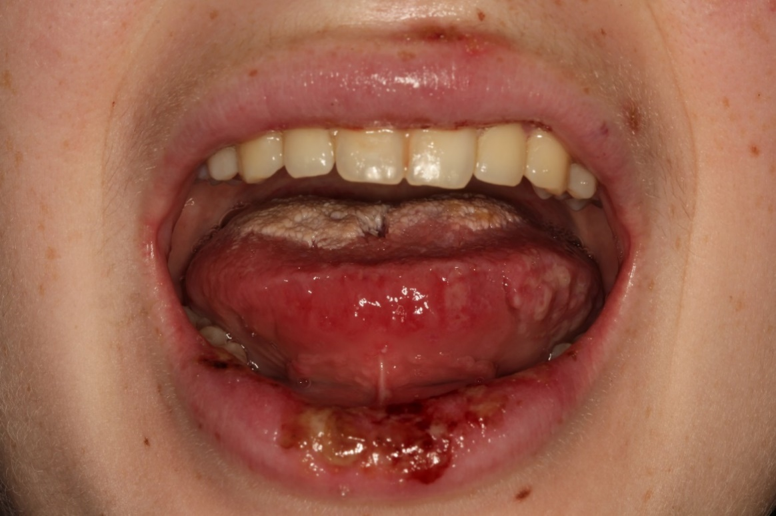

STUDENT/PROVIDER SCENARIO
In response to COVID-19, your school has implemented a virtual oral health rotation based on EPIC and live video consultations for patients with conditions affected the mouth and face.
You will be caring for Avery Parker, a 19 year old (adjust based on actor) who has a chief complain of “lip and mouth lesion”. Patient states his local student health services had electronically sent you the clinical image and laboratory test results.

Your task at this station (OSCE) is take a focused history of the patient’s concern, identify and review clinical information, and recommend management of the issue the patient brings up. You do not have to do a full physical examination.

Total time allocated for this station is 20 minutes

Available laboratory information
Lab tests:
CBC- WBC- 8.5K/uL; RBC- 5.5 cells/uL; Hb 12.5 g/dL; HCT- 38%;
IgM HSV-1- non reactive; IgG HSV-1- negative

Microbiology tests:
Viral (HSV Direct Fluorescent Antibody Stain) from the lower lip: positive for HSV-1

Clinical photo
Patient states it was sent electronically from student health services
FACULTY- ASSESSMENT CHECKLIST
Learner: _________________________________________ Date: ____________

Please rate from a scale of one (did not do/required complete guidance) to five (task done with complete independence) for each of the tasks provided in the table below.
1— “I had to do”—i.e., Requires complete hands on guidance, did not do, or was not given the opportunity to do
2— “I had to talk them through”—i.e., Able to perform tasks but requires constant direction
3— “I had to prompt them from time to time”—i.e., Demonstrates some independence, but requires intermittent direction
4— “I needed to be in the room just in case”—i.e., Independence but unaware of risks and still requires supervision for safe practice
5— “I did not need to be there”—i.e., Complete independence, understands risks and performs safely, practice ready

Section | TASK | Scale (1-5)*
Interpersonal and Communication Skills | Builds the relationship, introduction, eye contact, attention, not rushed,  empathy, asks how to address
 | Establishes the agenda (elicits concerns, agrees upon agenda)
 | Facilitates understanding (speaks clearly, avoids medical jargon, high priority information)
 | Summarize and confirm understanding (summarizes plan, elicits questions, uses teach back)
 | Showed listening body language (leans forward, looks at patient)
 | Used empathetic techniques (repeat feelings, legitimize concerns)
 | Appropriately admitted uncertainty, and, if applicable, offered to get more information for patient
 | Voices understanding of patient’s context (cost, transportation)
Medical Knowledge | History asked about prior HSV infection, mouth lesions, RAS?
 | Questioned about nature, onset, character, intensity, location, duration, aggravating/relieving factors, referral, associated symptoms regarding the lesion?
 | Ask whether cultures or blood work was done (to rule out viral infection)
 | Review clinical image and lab tests and explain the nature, etiopathology, and expected course of primary oral HSV infection
 | Explain the risks associated with primary oral HSV (dehydration, weight loss, autoinoculation, potential transmission via intimate contact during infectious phase)
 | Discuss management options including supportive care (hydration, diet, topical analgesics, NSAIDs). Explain the role of systemic anti-viral therapy.
 | Clear instructions and summary of clinical diagnosis and plan was given to the patient
Use of Technology | Asked the patient if he/she could see and hear with the technology
 | Make necessary adjustments for technologic issues
 | Access EPIC and My Chart for accessing clinical data and documenting visit notes
 | Remained patient-centered despite distractions
*Scale Adopted from The Ottawa Surgical Competency Operating Room Evaluation (O-SCORE)

Additional comments for the learner:

____________________________________________________________________________

____________________________________________________________________________

____________________________________________________________________________

Follow-up: Would any further learning activities be helpful to this learner? Yes / No

Specific skills to address:

____________________________________________________________________________

____________________________________________________________________________

____________________________________________________________________________

Evaluator Name:

________________________________________

