Waxaad Cunugaaga u Joogteyn Kartaa Ilko-Cadeyn Caafimaad Qabta!
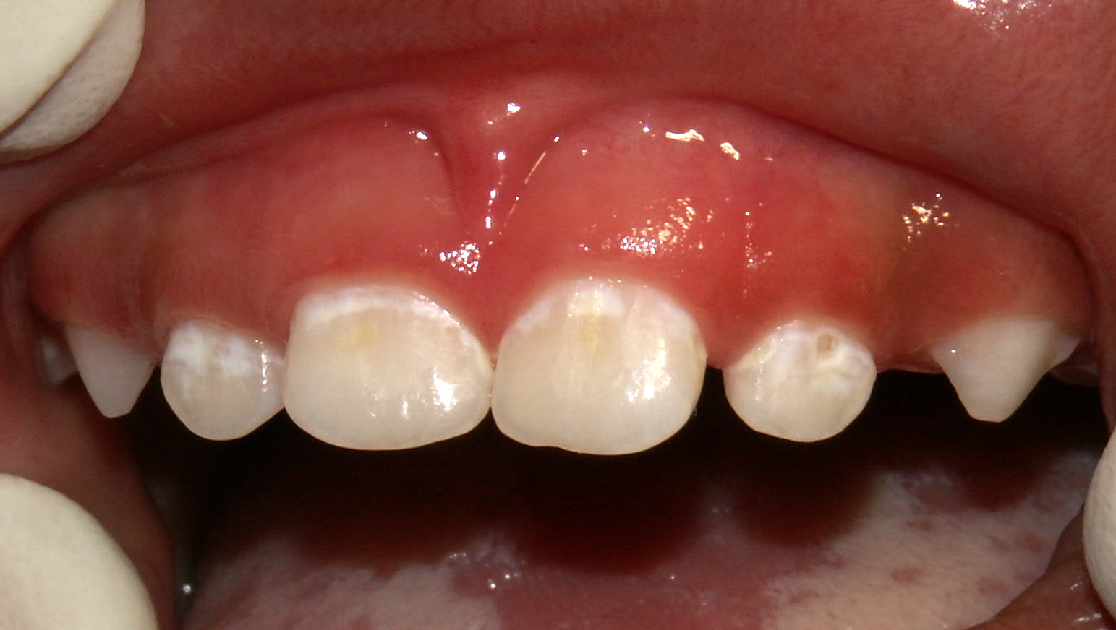
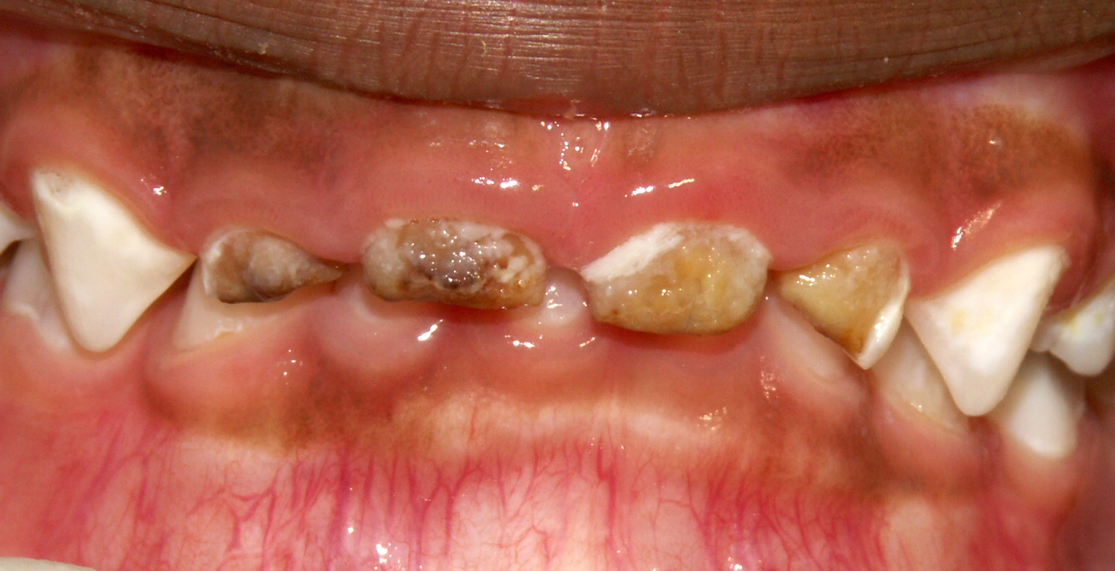
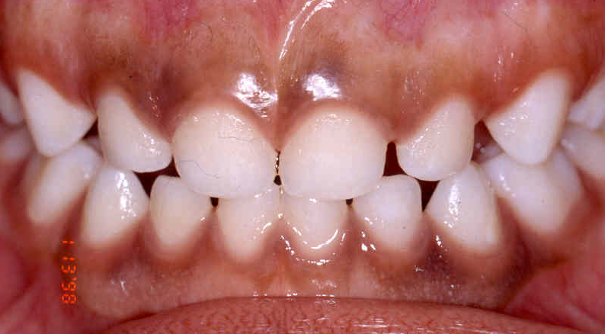
Ilko Caafimaad Qaba Bar cad iyo Daloolo soo hormaray Daloolo qotodheeraaday
Daloolada Ilkaha

Cuntooyinka-Fudfudud (Snacks) Snac ( (Snacks)

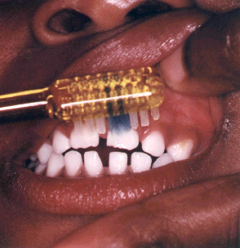
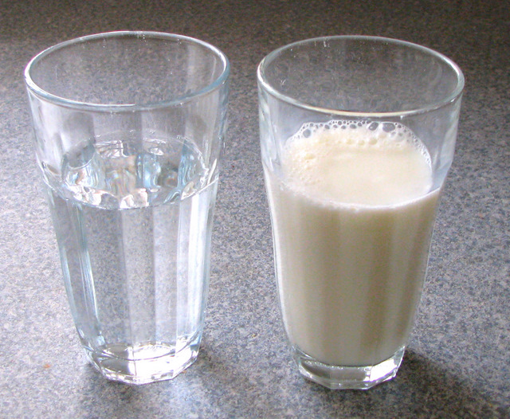
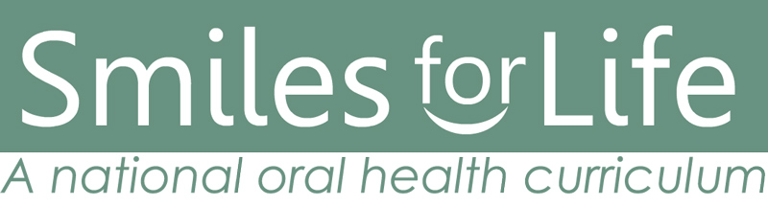


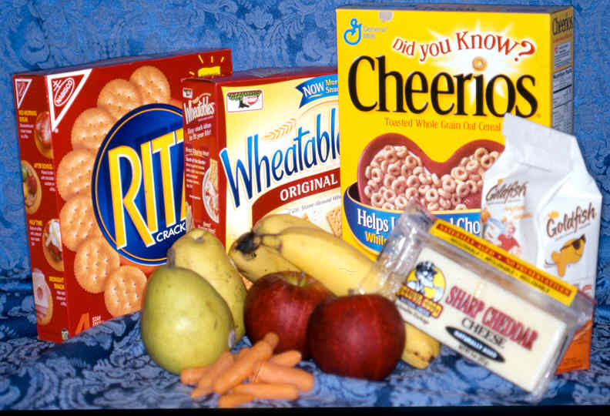
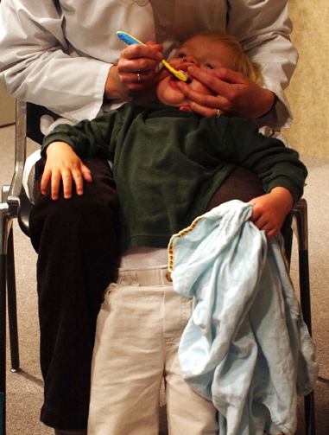
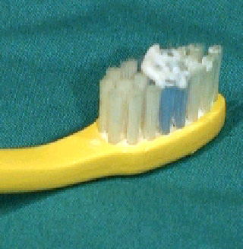
Marka aad cuntid cuntooyin sonkor leh, bakteriyada afku waxay sonkorta u bedeshaa aashito. Ashitadu waxay dhaciifisaa ilkaha waxayna sababtaa baro cad cad oo ilkaha ku dhasha. Hadii aad joogteysid cunida sonkorta, baraha cad cad waxay isu bedelayaan daloolo. Dalooladu waxay horseedi karaan infekshino khatar ah.

Sida hadba in badan aad ka cuntid cuntooyinka sonkorta leh ayaa hadba in badan ilkahaaga daloolo ugu abuurmi karaan.

•Hal cunto-fudud oo sonkor ka maran cuntooyinka dhexdooda
•Maya badsashada cuntooyinka fudud (No “grazing”)!

Farmaajo, Buskudyada, Miro daray-ah (cusub), Khudrooyinka , Cheerios saafi ah, Buskudyada xorshoshoda ah (pretzels)

•Cuntooyinka-fudfudud ee caafimaadka leh:

leh:

Basaasadaha (Bottels)

•Hay cunugaaga marka uu basaasad wax ku cabayo
•Basaasadaha u isticmaal caanaha la qaso iyo kuwa naaska oo keliya
•Maya in basaasadaha sariirta lala seexdo!
•Jooji isticmaalka basaasada marka la gaaro 12 bilood

Ilkocadayshada (Toothbrushing)

•Bilow mar alaale marka aad ilko aragtid!
•Buraash yar oo jilicsan
•In yar oo daawada ilkaha oo foloorayd leh
•Caruurta ka xafid daawada ilkaha in ay gaaraan

•Fariiso ama staag dusha dambe ee cunugaaga marka aad u cadayesid
•Caday cirridada iyo ilkahaba

•Maya cunto iyo cabbitaan toona cadayashada kaddib oo ah waqtiga seexashada
Koobabka (Cups)

•Bilow isticmaalka koobka 6 ilaa 9 bilood inta u dhaxaysa
•Ha u ogolaan cunugaaga in uu la meereysto basaasad ama koobka dhegaha leh midna

•Caruurta jirta sanad ama ka weymba sii caano ama biyo oo keliya cuntooyinka dhexdooda

Cunugaaga booqashadiisa ilkaha ee koowaad waa in ay ahaato marka uu gaaro 12 bilood

Developed by AB Douglass, MD, JM Douglass, BDS DDS, HJ Silk, MD
University of Connecticut Schools of Medicine and Dental Medicine

